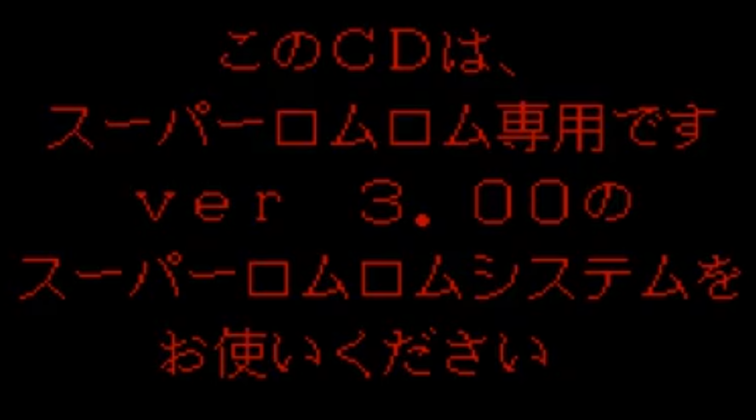

このＣＤは、

スーパーロムロム専用です

ｖｅｒ　３．００の

スーパーロムロムシステムを

お使いください

This is a SUPER CD-ROM2 disk.

Please only use it on a SUPER CD-ROM2 ver 3.00.

[voice segment]

“Thank you for waiting! Pretty Soldier Sailor Moon is finally on PCEngine!”

“A group of men wearing ominous masks appear out of nowhere. They’re after the Illusionary Silver Crystal, in order to resurrect the Dark Kingdom.”

“Two individuals hold the key to this mystery: Past Wiseman and Death Phantom…but who are they?”

“Ten warriors will fight throughout the streets of Juuban!”

“And don’t forget about me.”

“A masterfully crafted original story—a moving tale full of love and tears.”

“PCEngine Super CD-ROM2 Pretty Soldier Sailor Moon”

“Play it on your Super System Card!”

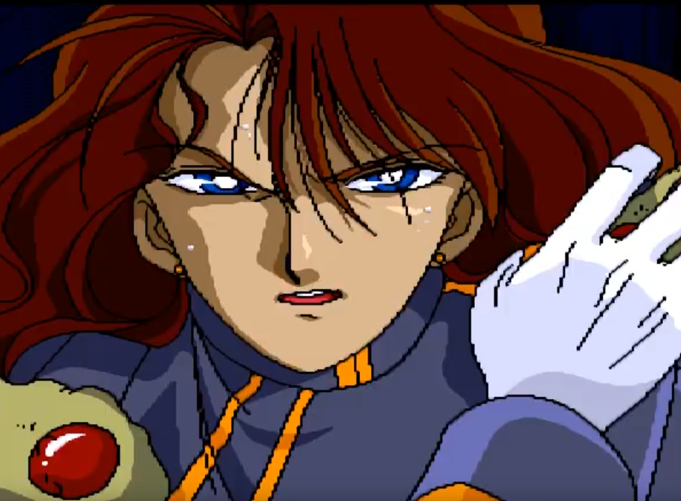

“I must...inform...Usagi...Tsukino...!”

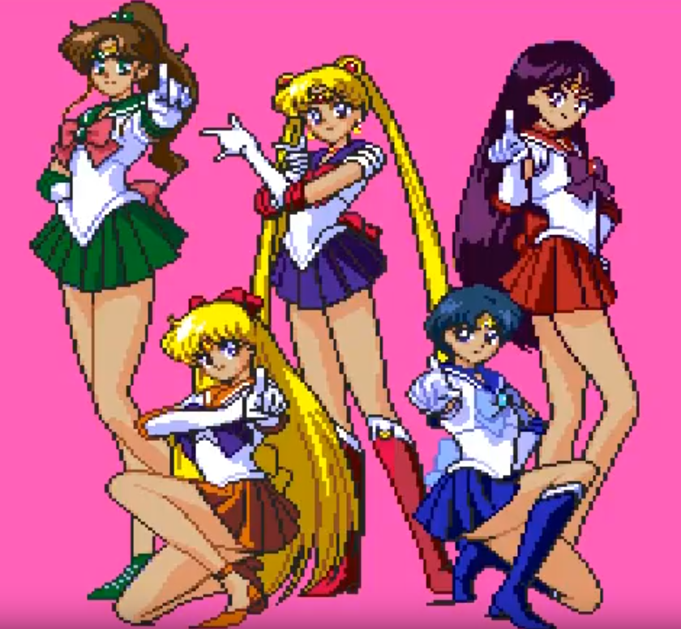

“I don’t know who you’re supposed to be, but let that man go!”

“Here they come…”

“The sailor-suited Pretty Soldier of Love and Justice—Sailor Moon!”

“Likewise—Sailor Mercury!”

“Sailor Mars!”

“Sailor Jupiter!”

“Sailor Venus!”

“In the name of the moon…”

“We’ll punish you!”

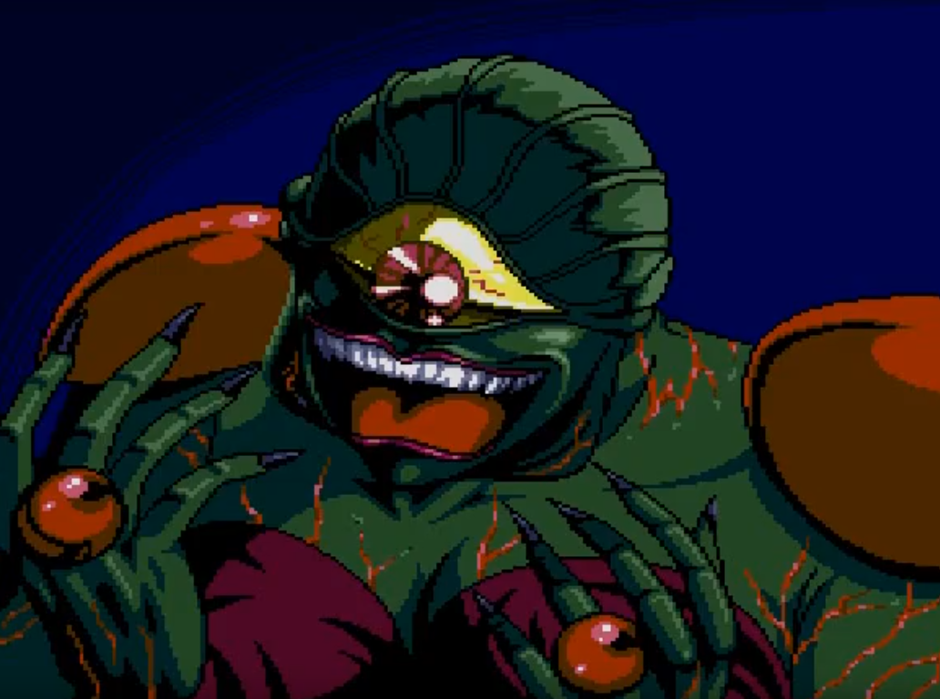

“Impossible! This can’t be happen—”

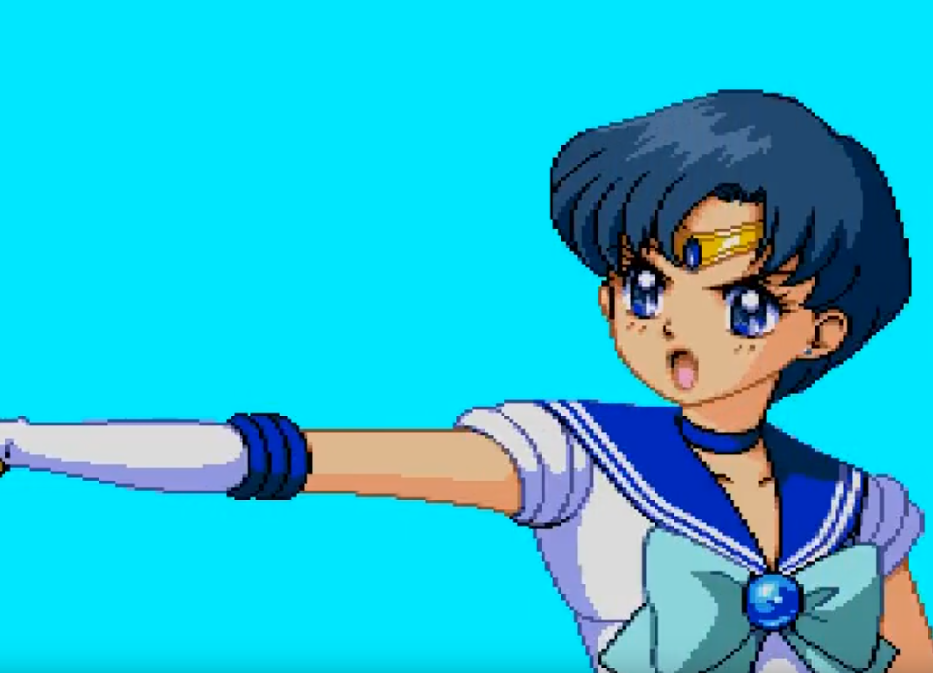

“Mercury Star Power!”

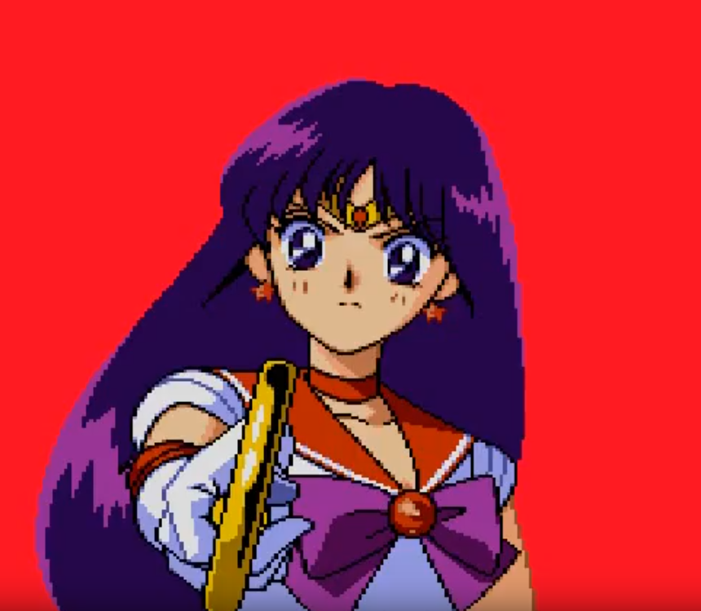

“Mars Star Power!”

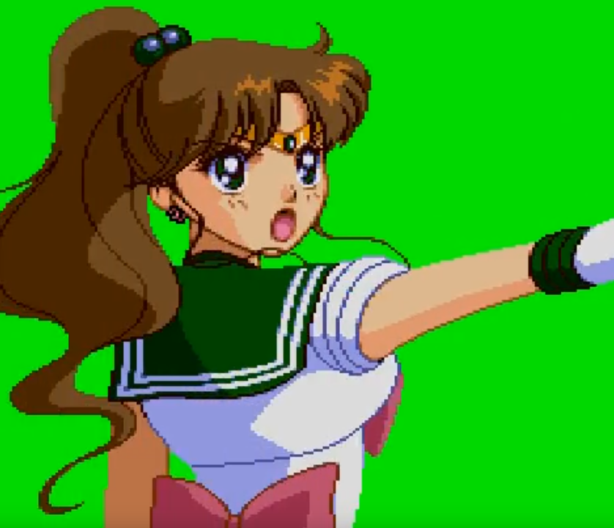

“Jupiter Star Power!”

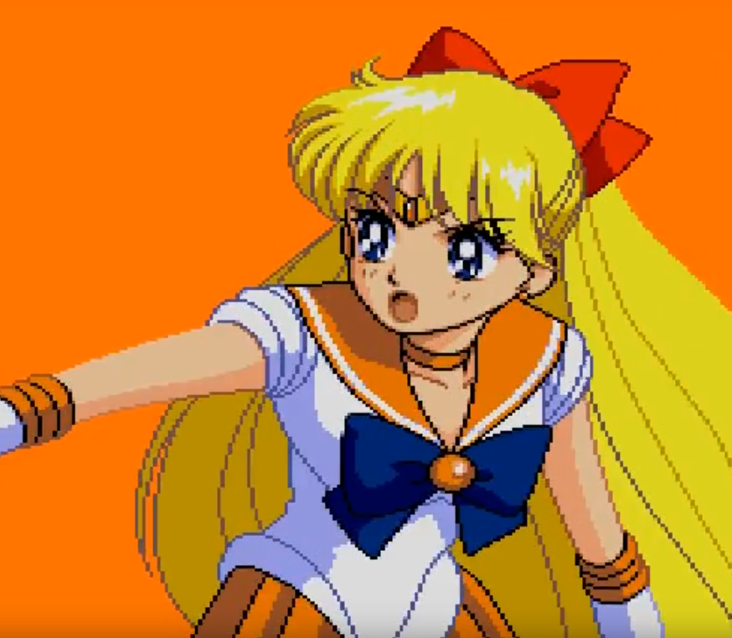

“Venus Star Power!”

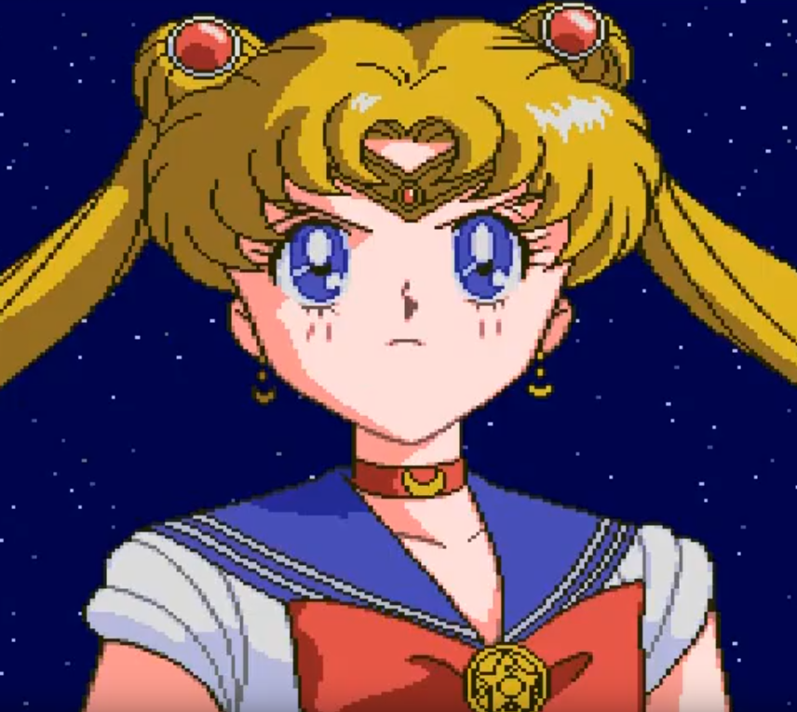

“Moon Crystal Power!”

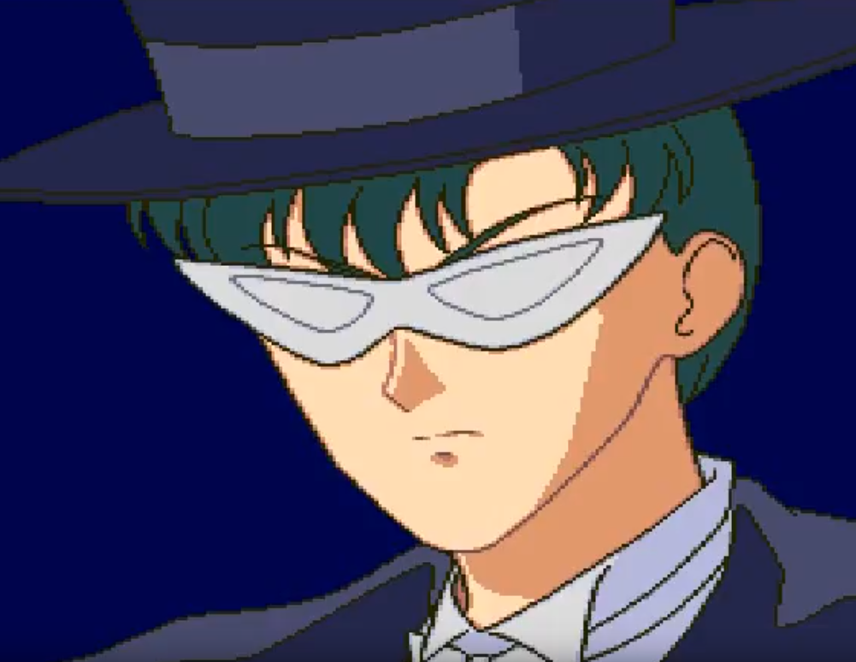

“Is there no way you can return to your former selves…?”

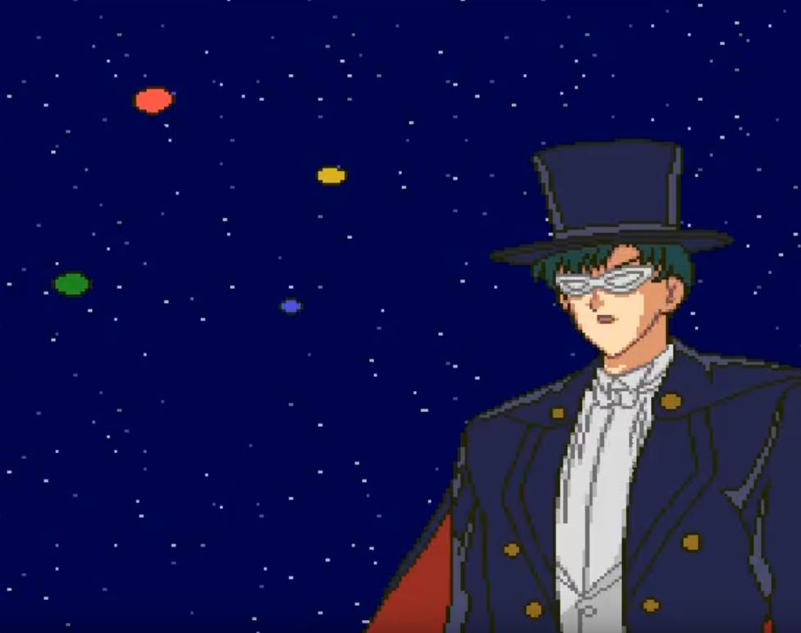

“Master... I’m glad we were able to see you once more.”

“I hope you can forgive us for the way we acted in this era…”

“May the two of you live in happiness.”

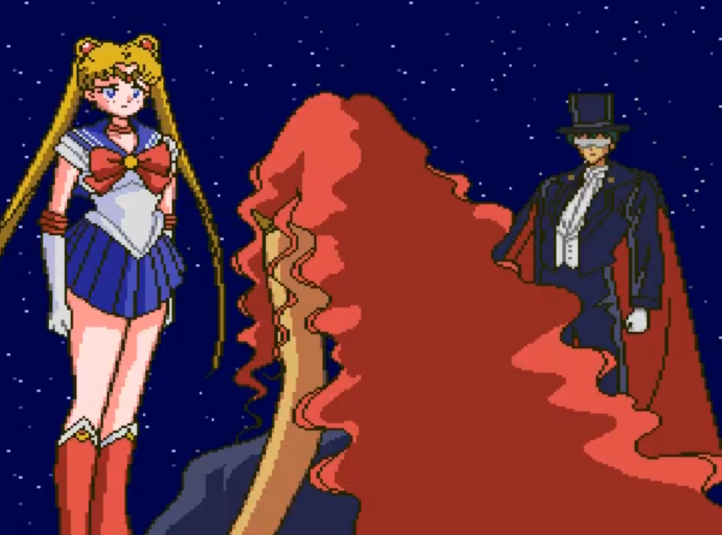

“What are you looking at? Just finish me off already!”

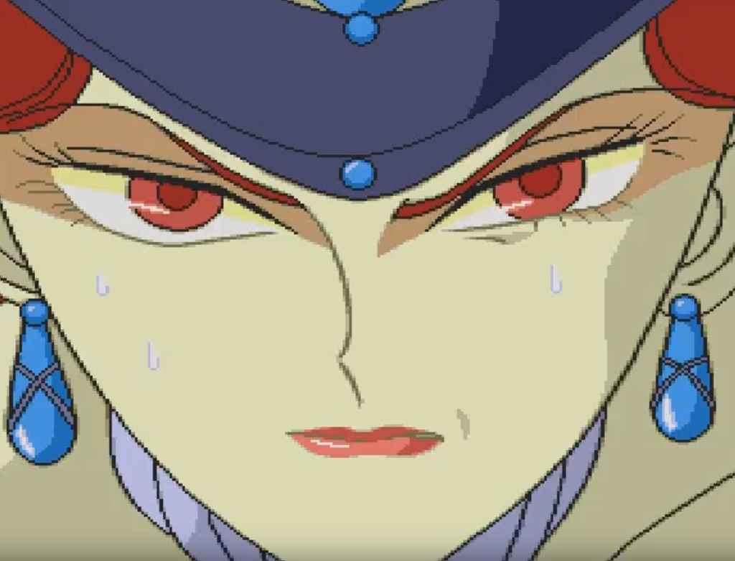

“Without that gem, I won’t be able to come back to life again.

There’s no better place for me than the world of the dead.”

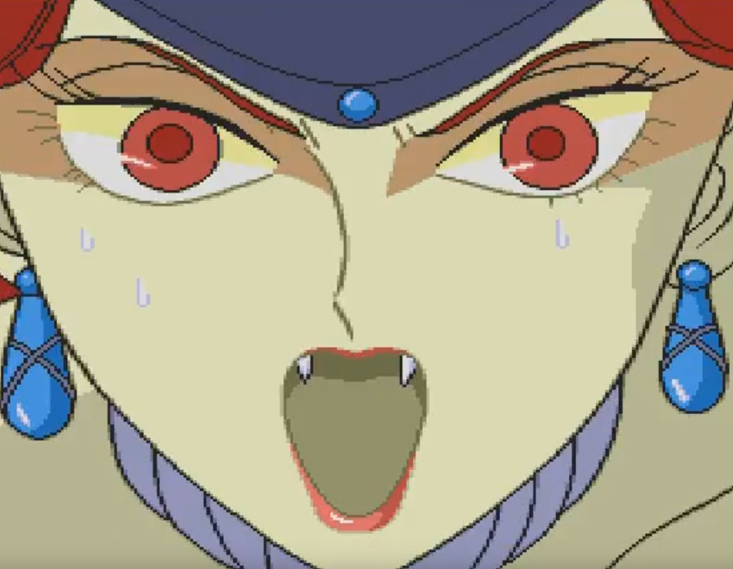

“What are you waiting for?!”

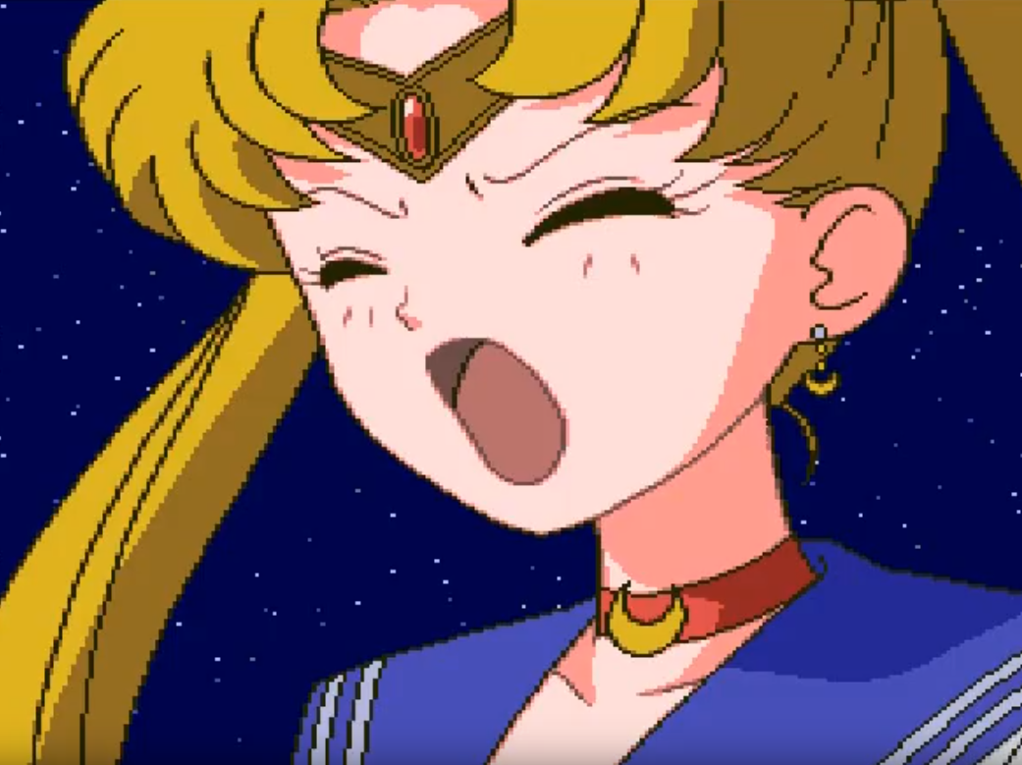

“Stop it! Why would you say something so sad? Isn’t this enough? Let’s just forget about the past, about all this fighting… Forget about all that.”

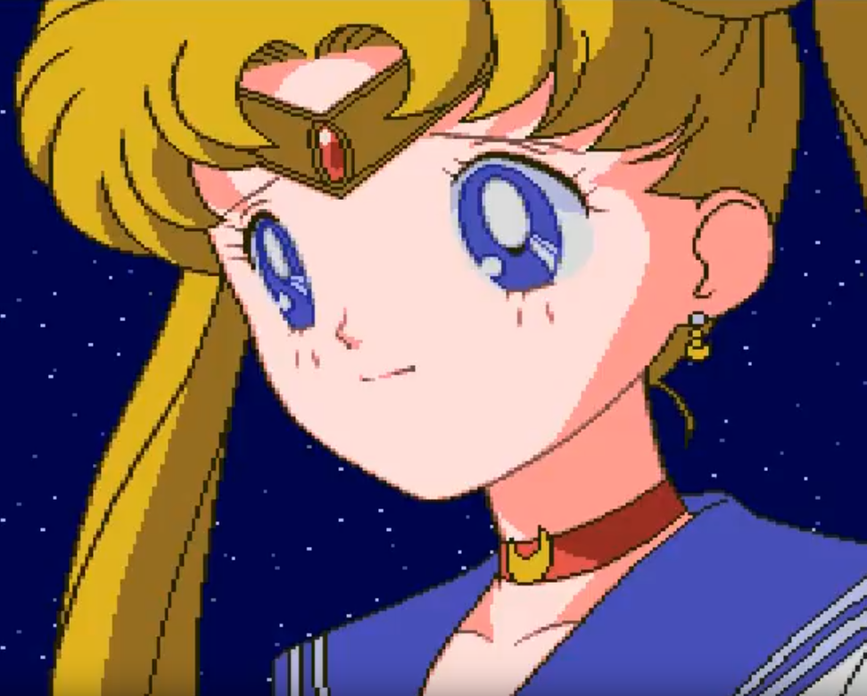

“I know! How about we become friends? After all, we’re the same. We both loved the same man.”

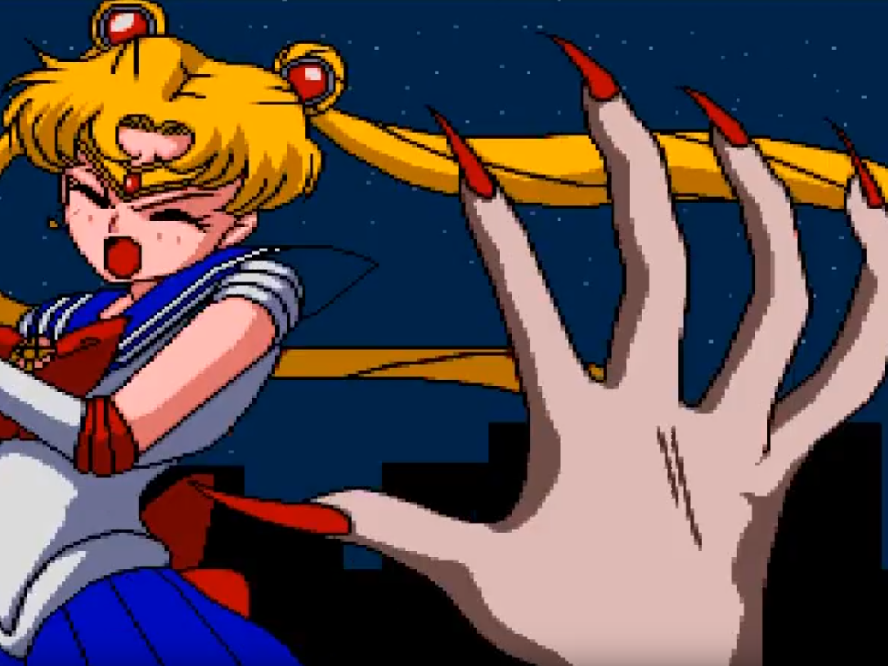

“Eek!”

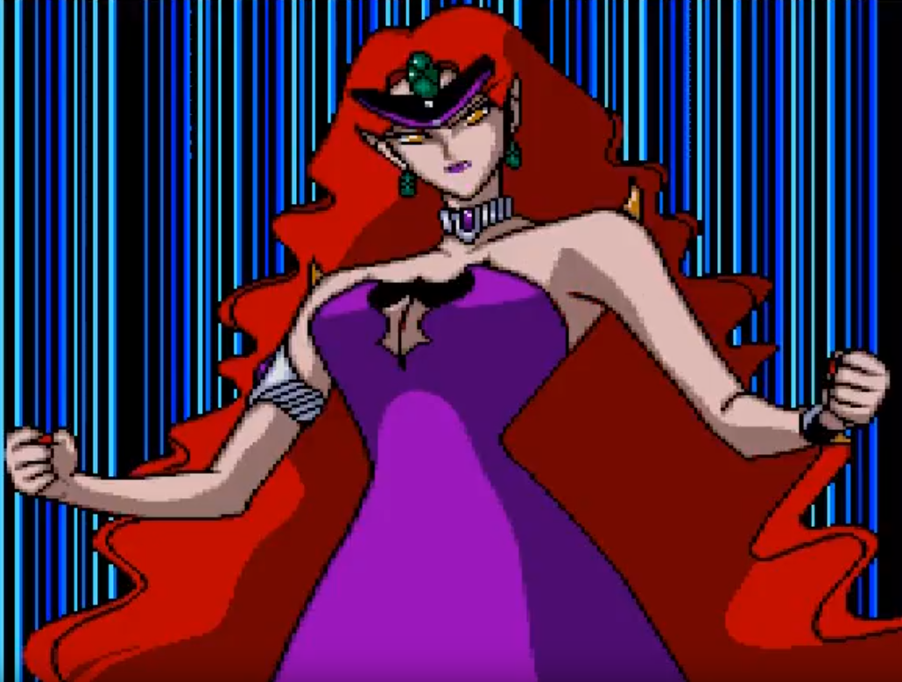

“Don’t you dare! You want to be ‘friends’? Don’t you know who I am?! I am the ruler of the Dark Kingdom, Queen— “

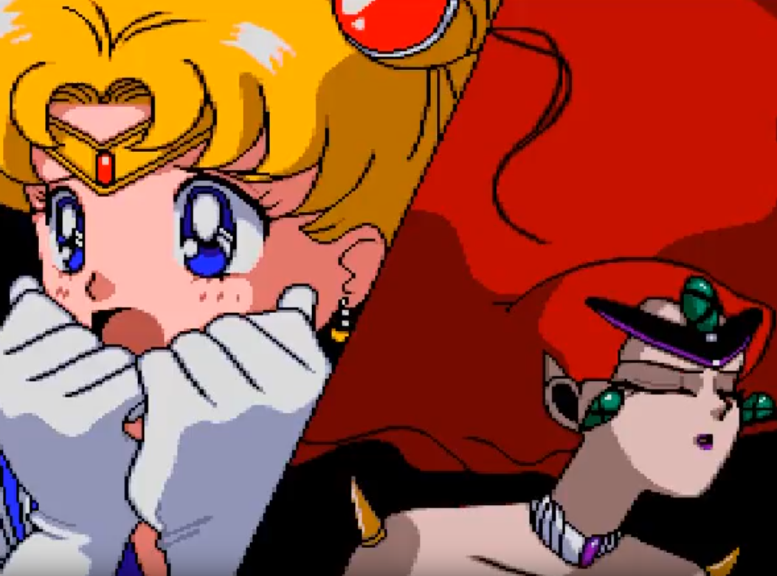

“Queen Beryl?!”

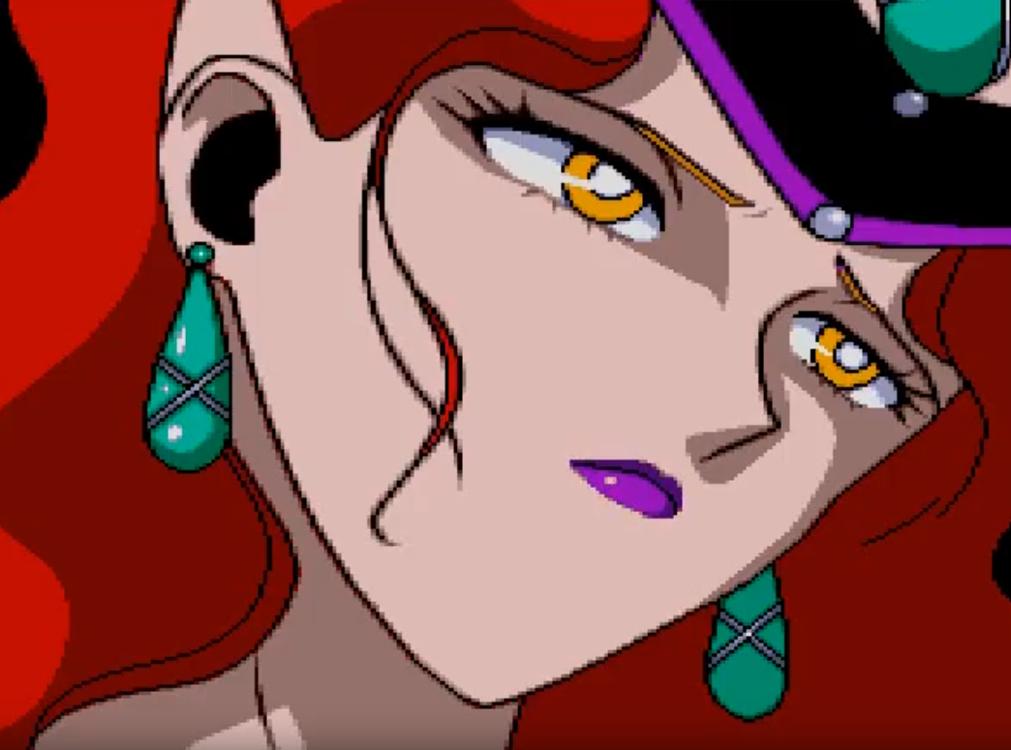

“I have no idea where you get that kindness from… You were always like that.”

“I… I was always afraid of that kindness.”

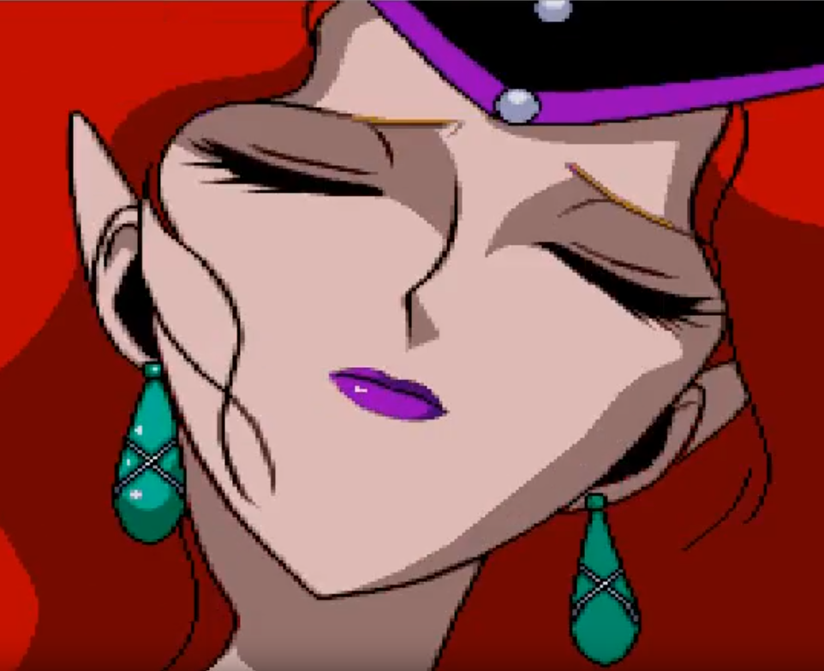

“I was afraid of what would happen if Endymion were to witness that kindness.”

“I was afraid…that I’d forgive you, if I were to stay by your side…”

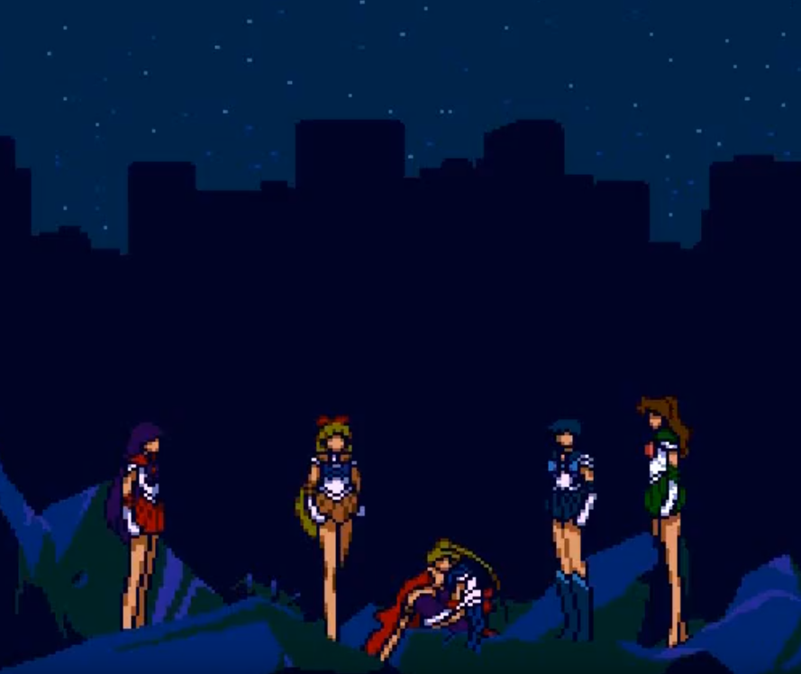

“Queen Beryl? Queen Beryl!”

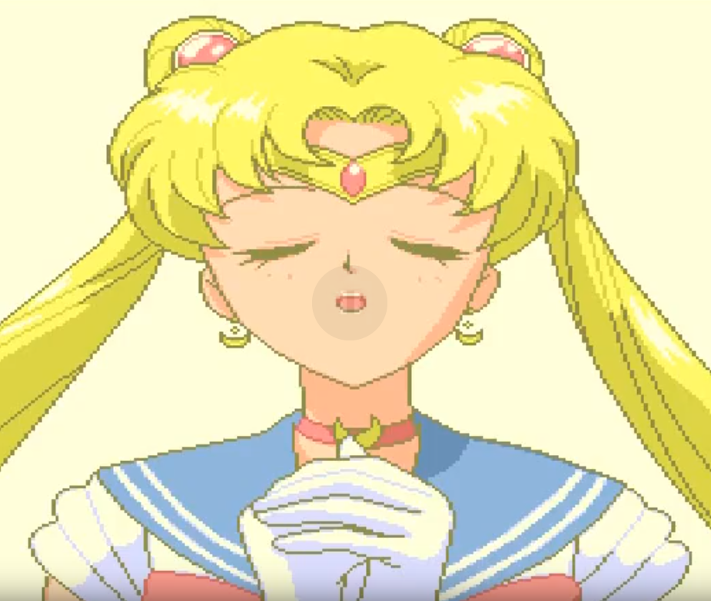

“O Silver Crystal, listen to my wish. Let these people reincarnate, like us. Let them live in a peaceful world, free from strife…”

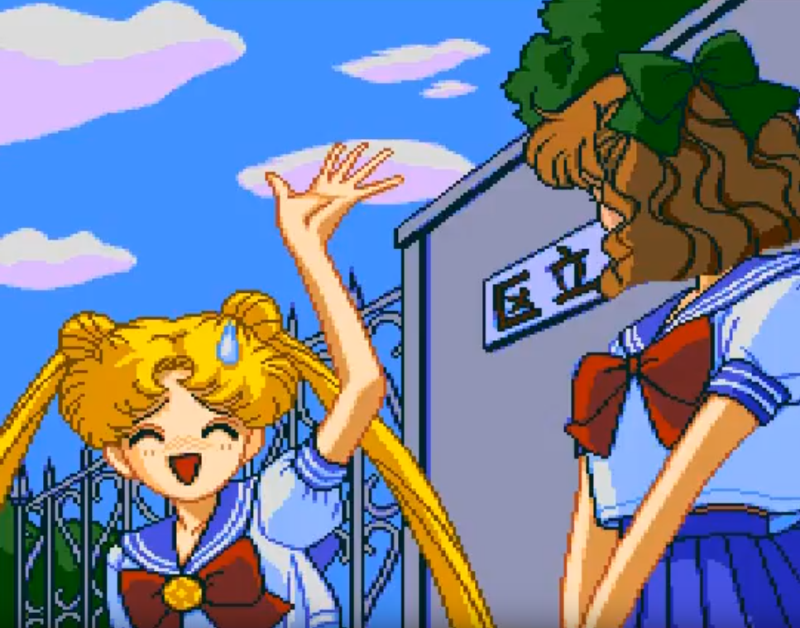

“Sorry! Did you wait long, Naru-chan?”

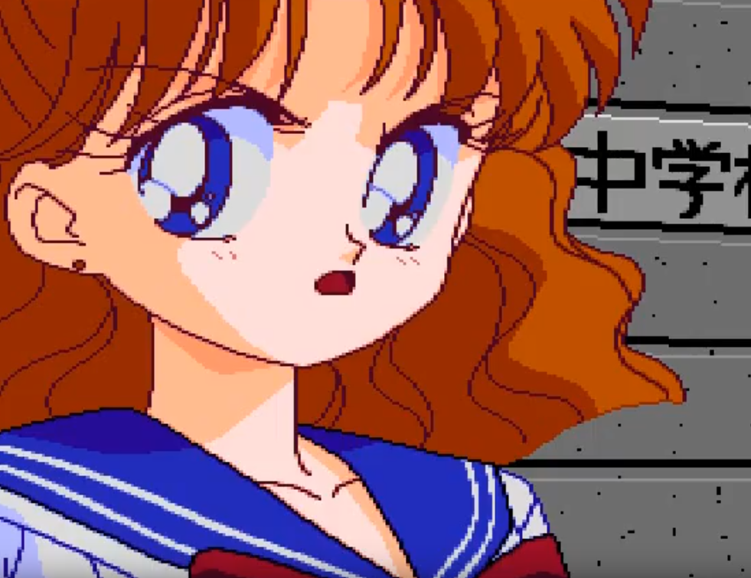

“You’re late, Usagi! What were you doing?”

“Sorry, sorry. I was caught by Haruna, you know how that goes.”

“Well, you’ll be carrying the flowers, then.”

“Doyeh! Why do I have to bring flowers to Umino?!”

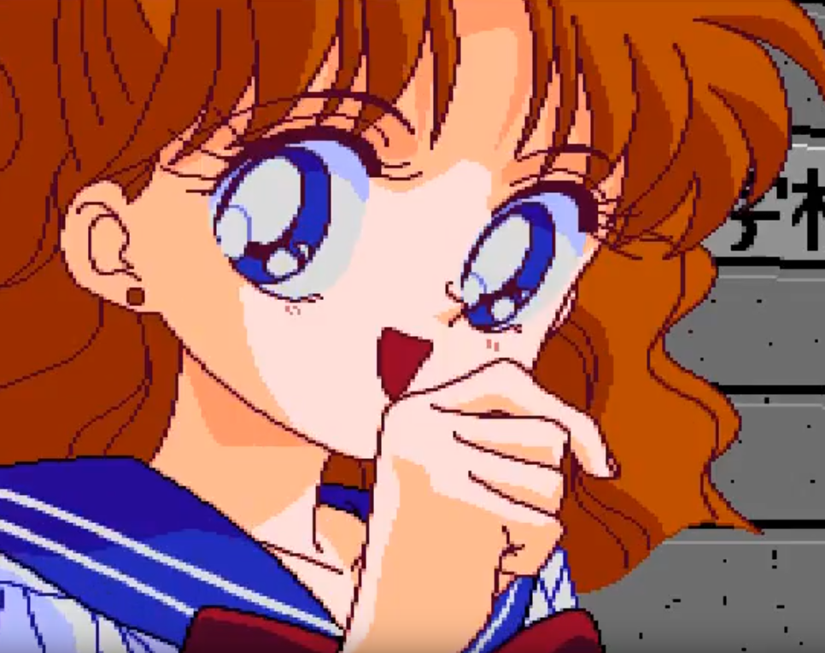

\*giggle\* “I’m just kidding.”

“You are?”

“But we’re splitting the cost!”

“Ehhh? But I’m almost out of pocket money this month!”

“No buts! I’ll get mad if you won’t pay up!”

“Hey! W-Wait up, Naru-chan!”

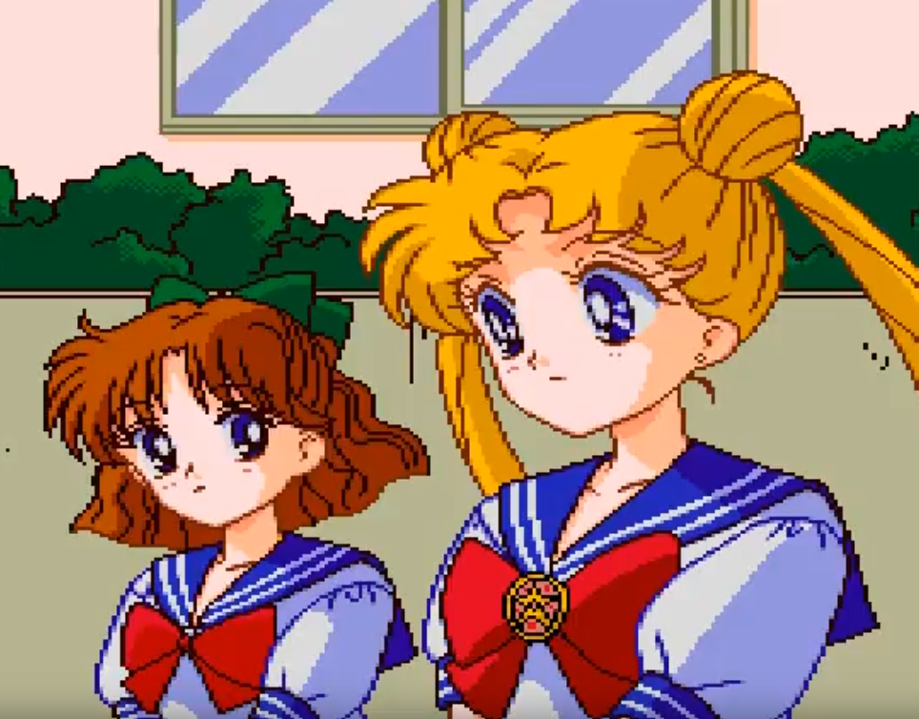

“But why do I have to visit Umino too, anyway?”

“That’s, uhmm... It’s the first time I go to his home, and...”

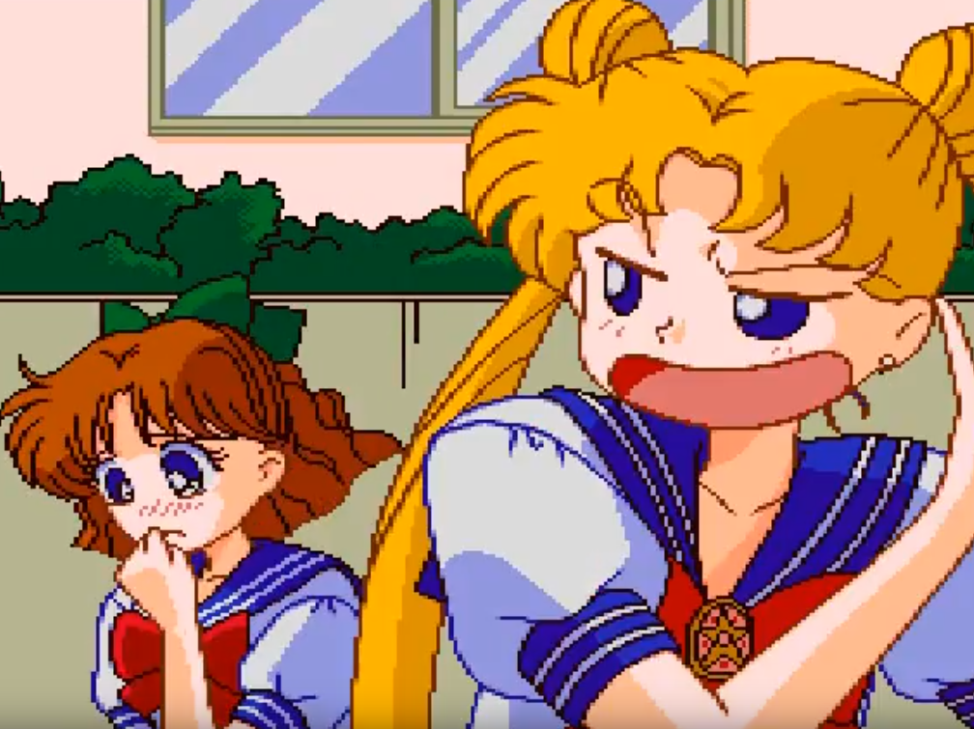

“Ohh, so it’s because you’d feel helpess without me, huh?”

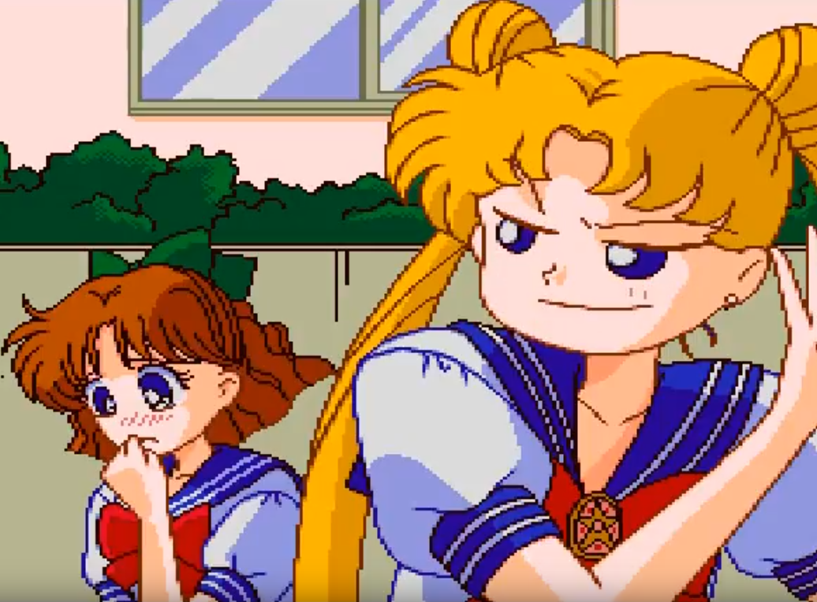

“Are you sure, though? Won’t I get in the way?”

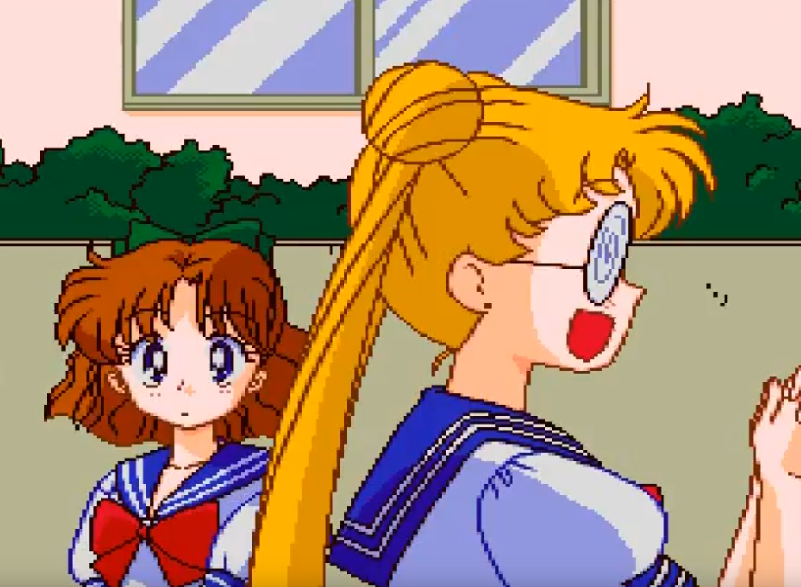

“Naru-chan! You came to see me? I’m so happy!”

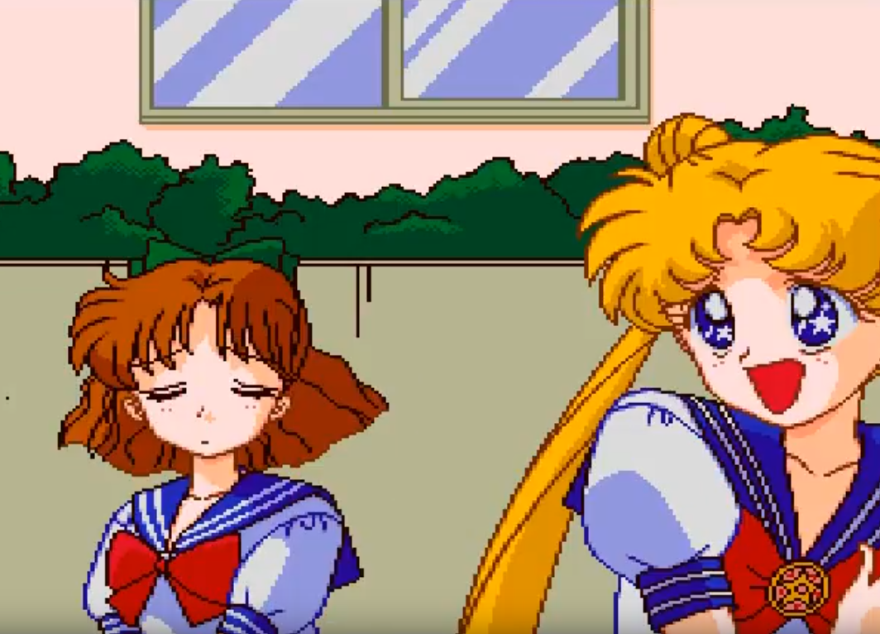

“Oh, Umino-kun, of course I’d come!”

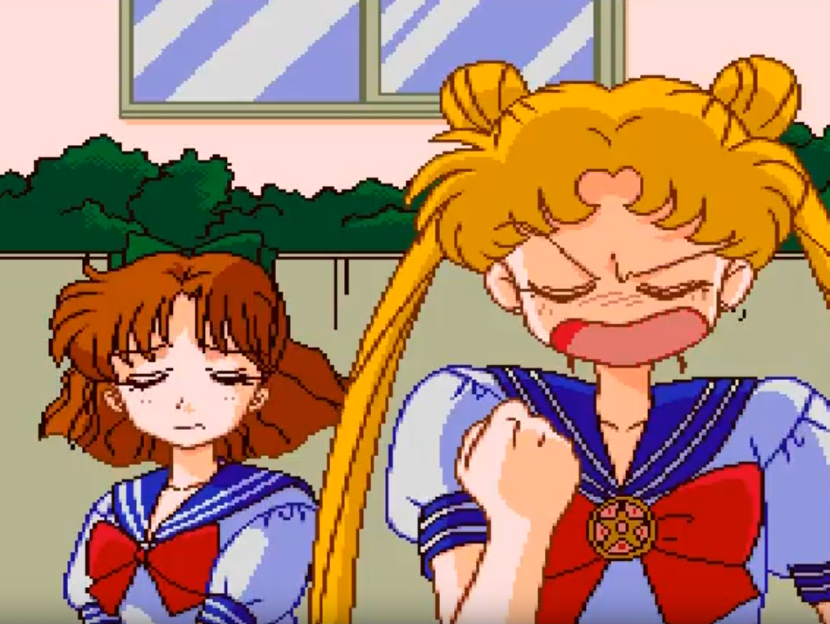

“No words are needed between two lovers. As they gaze into each other’s eyes, Umino and Naru-chan—"

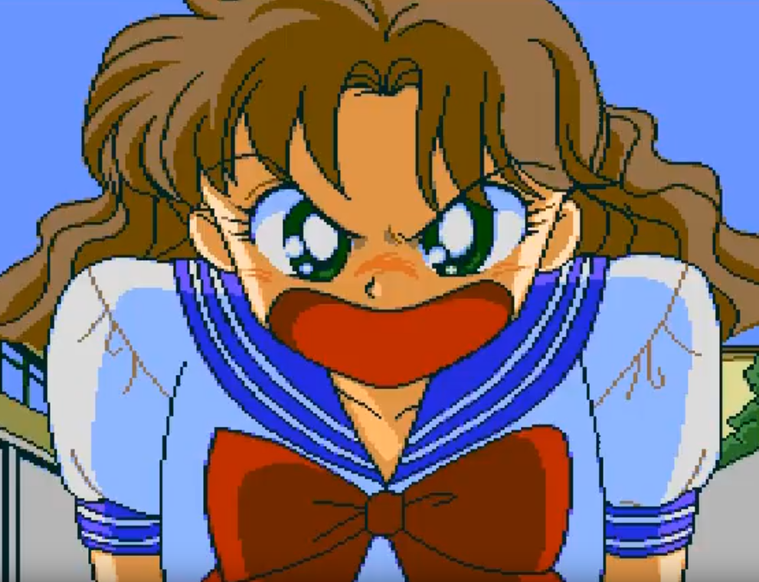

“Cut it out, Usagi! What’s that supposed to be?! I told you, there’s nothing between Umino and I!”

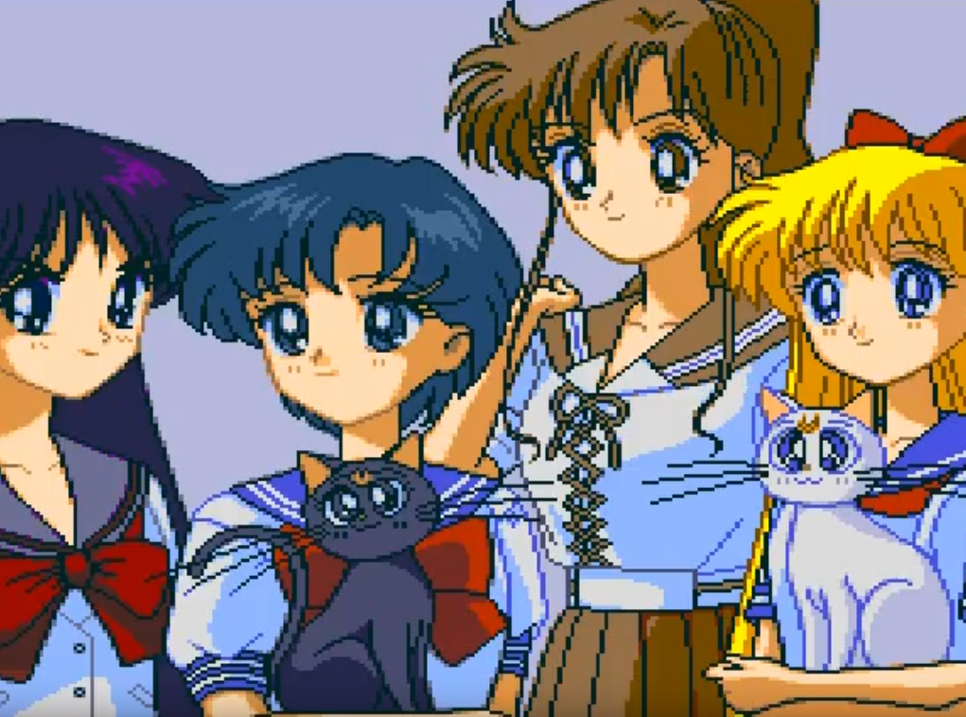

“I’m glad to see she’s doing well.”

“In the end, we never figured out who or what Death Phantom really was.”

“At any rate, now the battle against the Dark Kingdom is truly over.”

“Now Queen Beryl, Nephrite, and everyone else will be able to live a life free from conflict.”

“I hope so, too.”

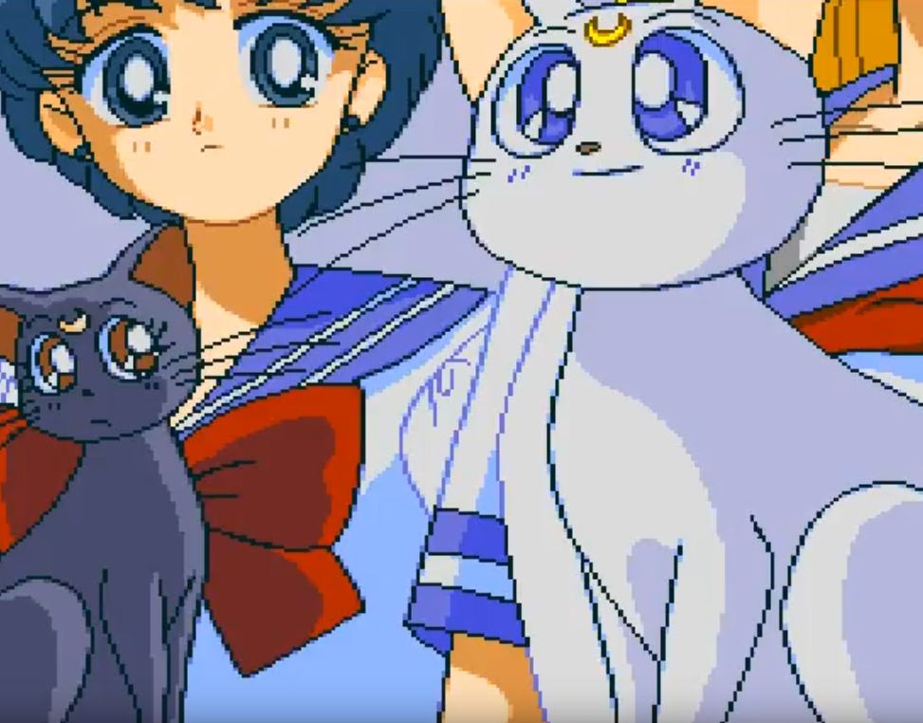

“I guess Usagi really is the Princess.”

“What brought this on, Artemis?”

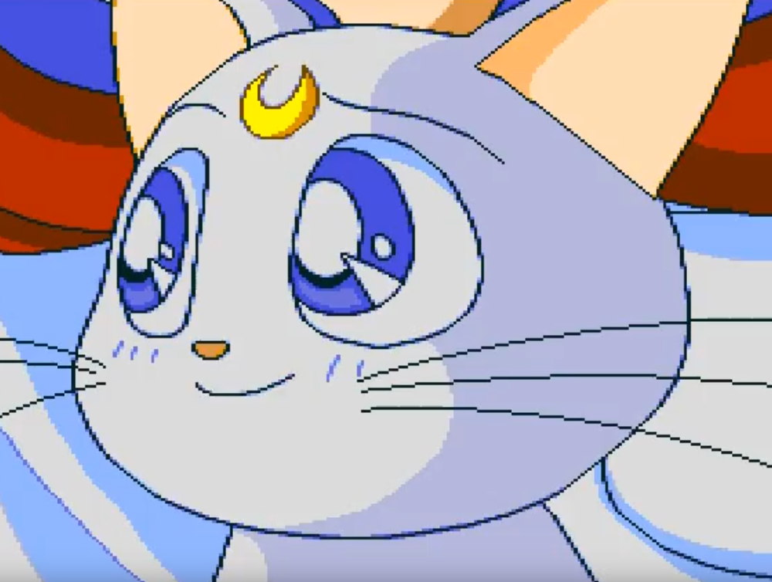

“It’s just that, even though Queen Beryl was her sworn enemy, she still felt sad for her, even cried for her. You wouldn’t think that little body of hers could hide that amount of love energy.”

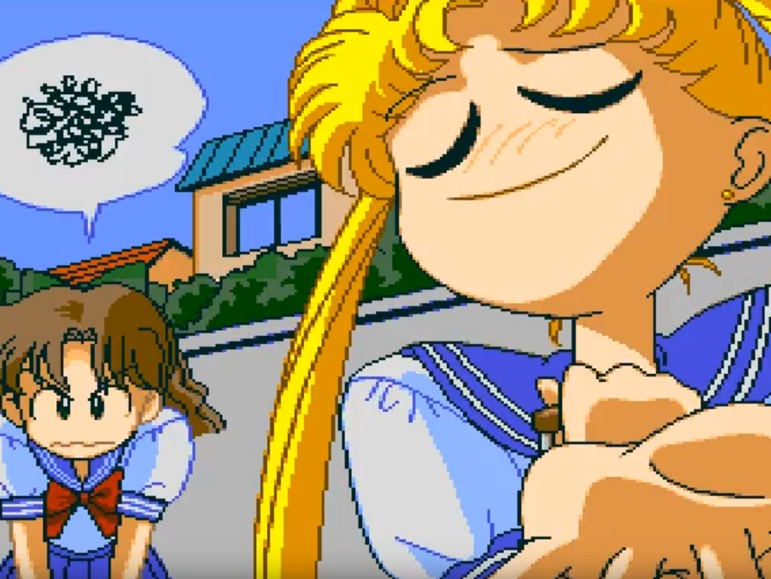

“Naru-chan! Ahh, Naru-chan!”

“Usagi!”

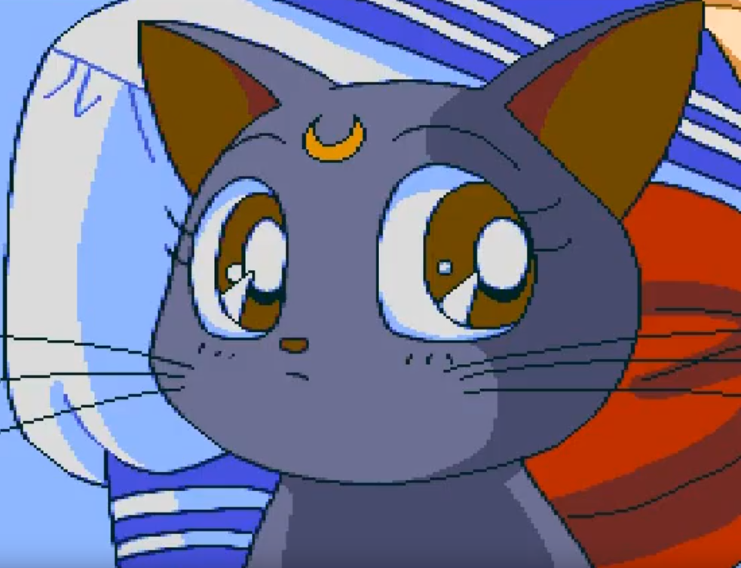

“…Are you sure about that?”

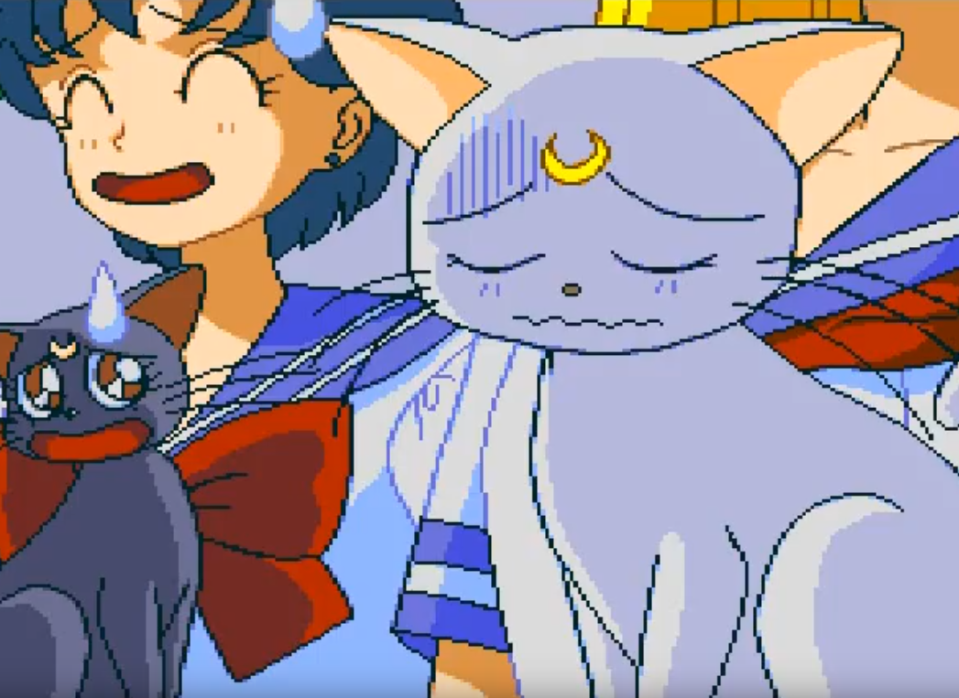

“…Well...”

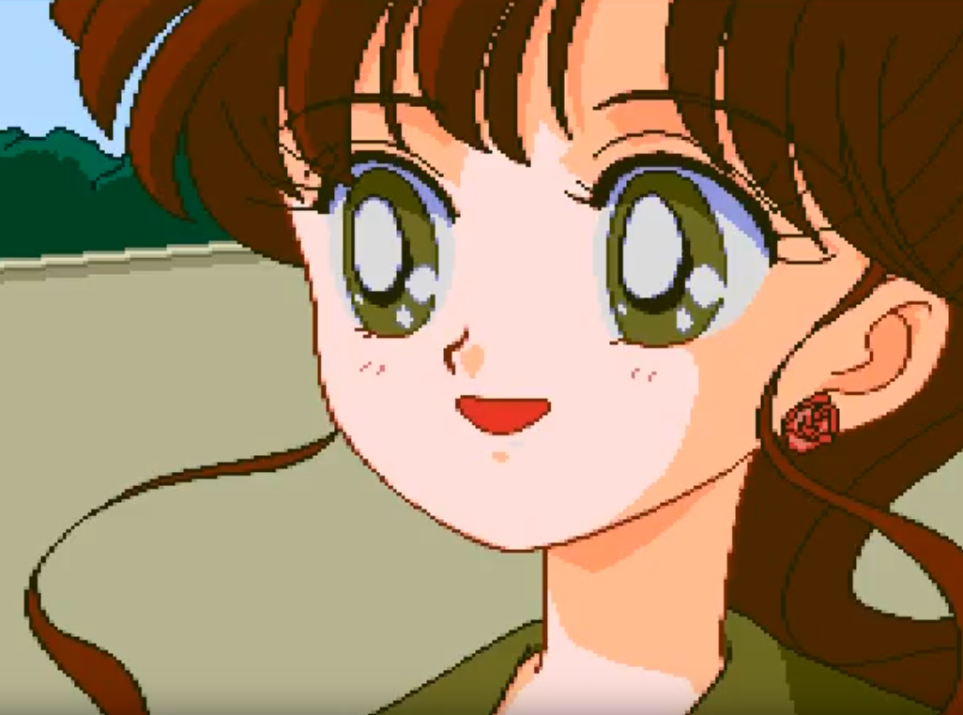

“What matters is that Naru-chan and Umino are getting along well, now.”

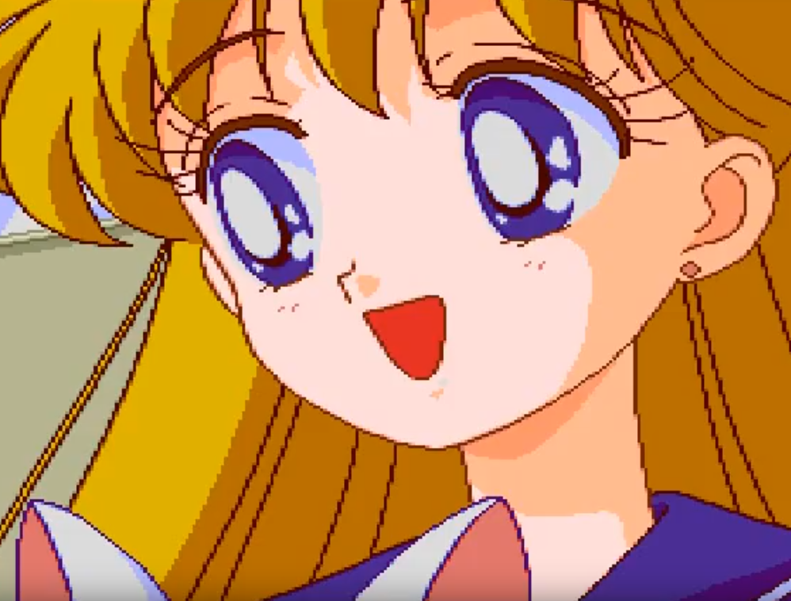

“Like the saying goes, ‘After a storm comes a calm’.”

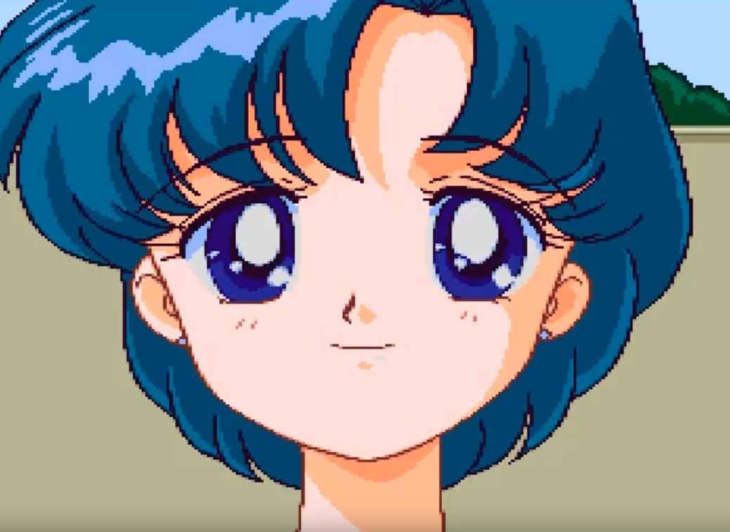

“Minako-chan.”



“Eh? A-Ami-chan, did I get that wrong?”



“No, it’s correct.”

“Oooh”

“Ehh? \*giggle\* Oh wow.”

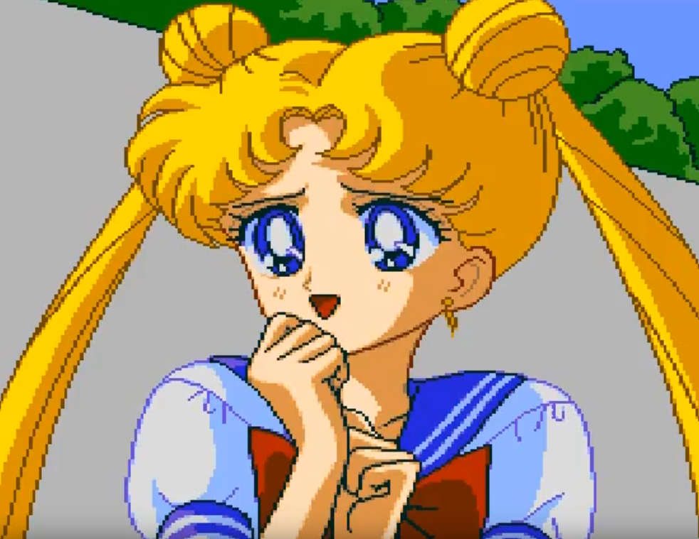

“Umino-kun, no! We can’t kiss yet! We’re still in middle school!”

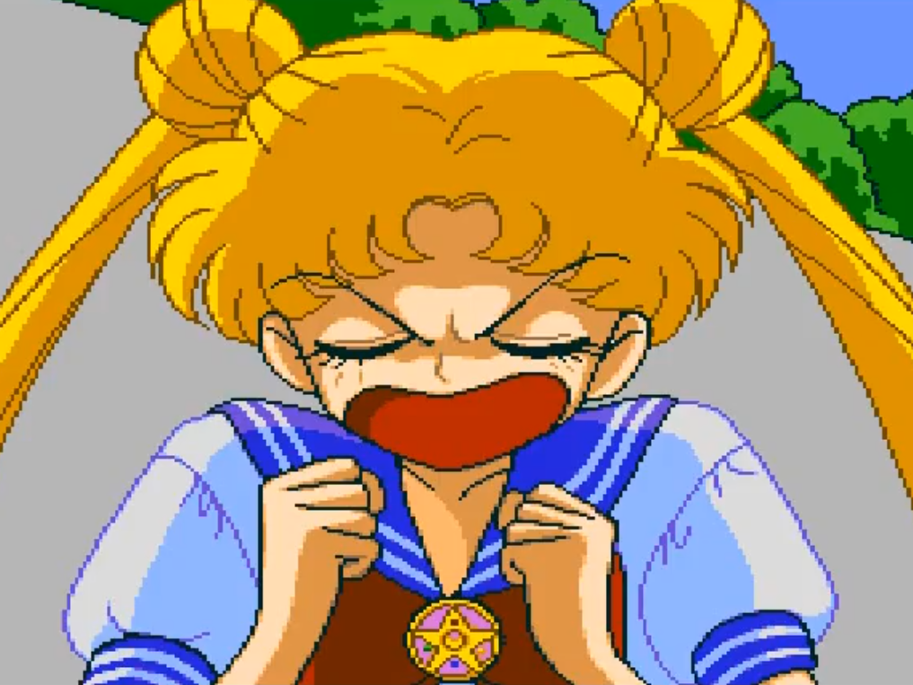

“Naru-chan tries to hold him back,”

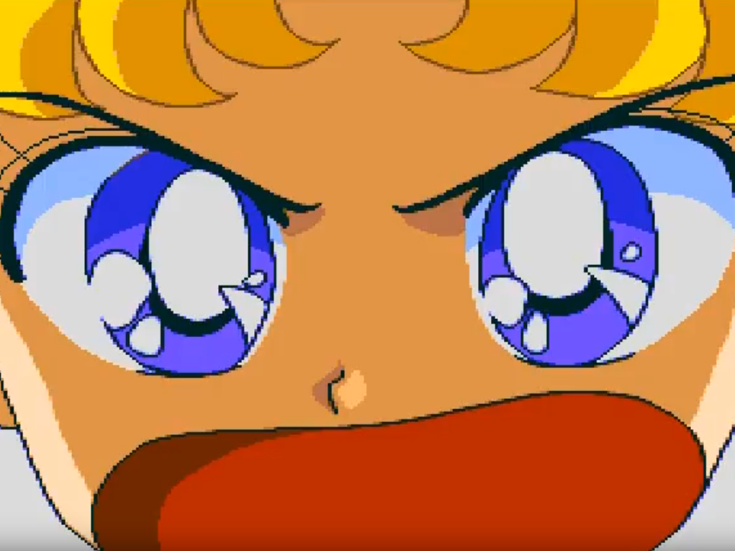

“But her maiden arms cannot stop a healthy young man.”

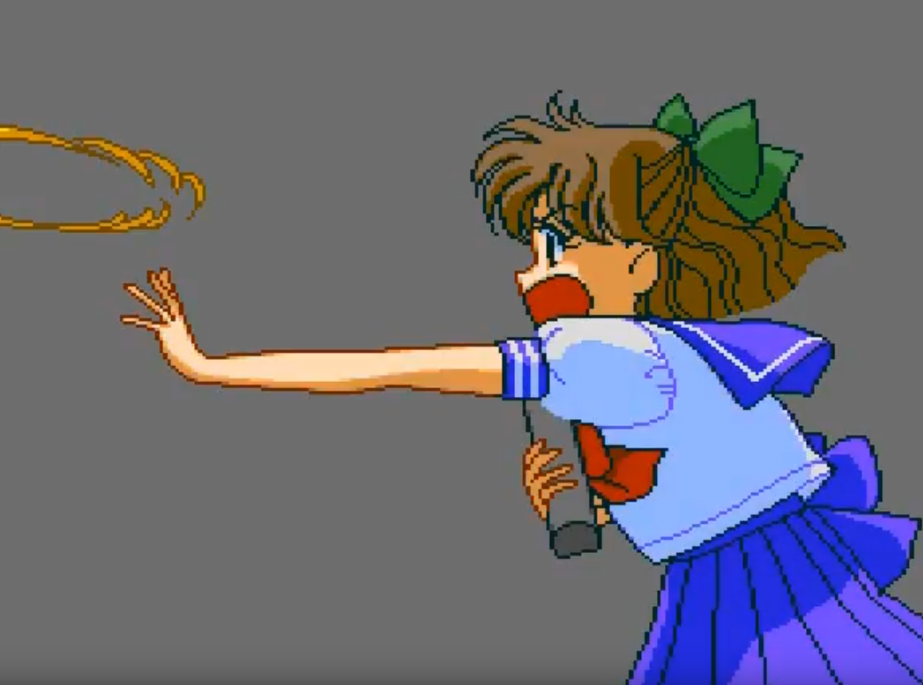

“Usagi! Will you cut it out already?!”

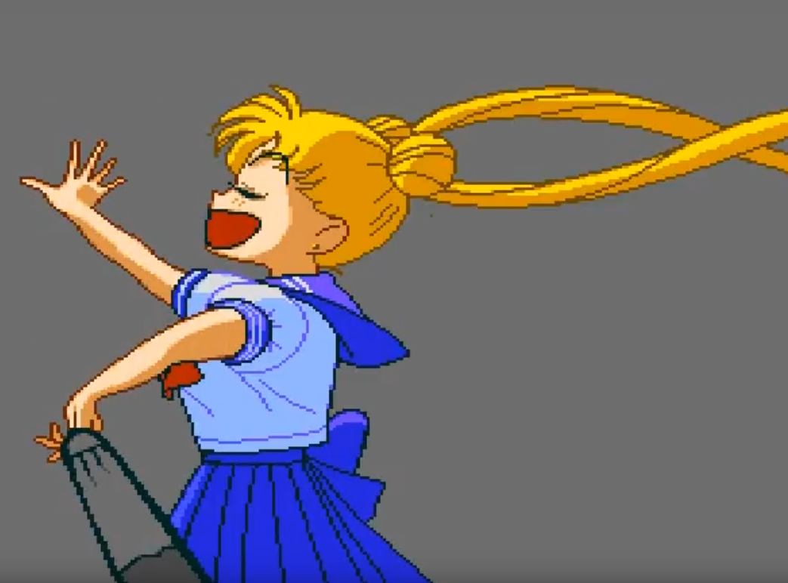

“Naru-chan! You are my sun!”

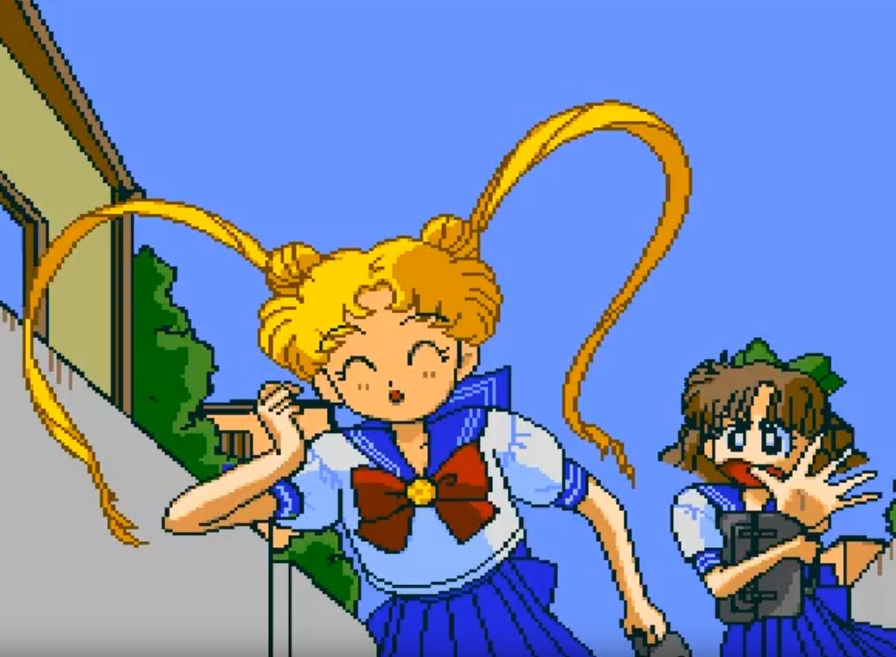

“Hold it!”

\*whistle\* “How passionate!”

“Usagi!”